**ELEC-E7250 - Laboratory Course in Communications Engineering**

Measurement report: Linear time-variant channel

Group members: Xingji Chen and Zheyuan Liu

1. **2-tone measurements of spaced-time spaced-frequency correlation**

* Compute the correlation between signal amplitude values for each frequency separation. You can use Pearson’s correlation coeﬃcient, available as standard function in Matlab/Octave.
* Plot the measured correlation.
* What is the approximate coherence bandwidth of the fading signal, i.e. where correlation is above 0.5.

|  |  |
| --- | --- |
| frequency separation | Pearson’s correlation coeﬃcient |
| 100 kHz | 0.8294 |
| 200 kHz | 0.5449 |
| 500 kHz | -0.0131 |
| 700 kHz | 0.1638 |
| 1 MHz | 1.0000 |



The approximate coherence bandwidth of the fading signal is 200 kHz.

1. **Measurement of LCR and AFD**

* Plot the power of the signal over time. What is the dynamic range? What is the average power?
* Determine the level crossing rate and average fade duration using *R* = *Pavg* −5dB.
* Can you explain diﬀerences in LCR and AFD between 2-tap and 1-tap channels and narrowband and wideband signals? Hint: 2-tap channel is same as in 2-tone measurement with same frequency correlation properties.

1. Narrowband signal, 1-tap channel



Dynamic Range: 23.1705 dBm

Average Power: -29.7289 dBm

Level Crossing Rate: 11 crossings/s

Average Fade Duration: 0.012649 s

1. Wideband signal, 1-tap channel



Dynamic Range: 28.3943 dBm

Average Power: -24.8897 dBm

Level Crossing Rate: 11.6667 crossings/s

Average Fade Duration: 0.012355 s

1. Narrowband signal, 2-tap channel



Dynamic Range: 22.9053 dBm

Average Power: -28.7166 dBm

Level Crossing Rate: 9 crossings/s

Average Fade Duration: 0.014681 s

1. Wideband signal, 2-tap channel



Dynamic Range: 21.0716 dBm

Average Power: -22.527 dBm

Level Crossing Rate: 7.3333 crossings/s

Average Fade Duration: 0.010784 s

1. Diﬀerences in LCR and AFD between 2-tap and 1-tap channels and narrowband and wideband signals.
   * **1-Tap Channel:** This refers to a single-path or flat-fading channel where all frequency components of the signal fade simultaneously and to the same extent. There is only one path between the transmitter and receiver, or multiple paths are combined in such a way that they cannot be resolved.

**LCR:** In a 1-tap channel, the LCR might be lower because the entire signal fades in unison, resulting in fewer level crossings.

**AFD:** The AFD tends to be longer since the signal will remain below a certain level until the whole channel condition changes.

* + **2-Tap Channel:** This represents a multipath channel with two distinct paths that can cause different delays and amplitude changes to the signal components. This is similar to the two different frequencies in 2-tone measurements and suggests a frequency-selective fading.

**LCR:** In a 2-tap channel, the LCR can be higher because different frequencies fade independently, potentially causing more frequent level crossings.

**AFD:** The AFD in a 2-tap channel might be shorter due to the signal experiencing rapid changes in different frequency components.

* **Narrowband Signals**: These are signals with bandwidth smaller than the coherence bandwidth of the channel. Therefore, the signal experiences flat fading where all parts of the signal fade similarly.

**LCR**: The LCR for narrowband signals will be lower because the signal components tend to fade simultaneously, resulting in fewer level crossings.

**AFD**: The AFD will be longer as the entire signal tends to stay below the threshold for extended periods when fading occurs.

* **Wideband Signals**: These are signals with bandwidth larger than the coherence bandwidth of the channel, and thus, different parts of the signal can fade independently (frequency-selective fading).

**LCR**: The LCR for wideband signals is higher since different frequency components of the signal can cross the level threshold independently and at different times.

**AFD**: The AFD will be shorter because individual frequency components will fade in and out more quickly, resulting in shorter durations below the threshold level.

1. **Measurement and analysis of LTV system functions**

How does the impulse response look compare to the power delay proﬁle visible in channel emulator? Can you explain why it looks diﬀerent?

* + The power delay profile visible in the channel emulator is several independent bar graphs, which show the relative signal strength at different time delays. However, the actual measured impulse response differs from the power delay profile. In the GSM signal, the impulse response has several distinct peaks, which can be distinguished even though there is some overlap, and correspond to the power delay profile. In the LTE signal, the impulse response also has peaks, but the overlapping part is significant, and the number of peaks is less than the number of peaks in the power delay profile. This may be because the actual measurement equipment has a limited time resolution, which may not be able to accurately distinguish very close multipath components. System noise and random attenuation during the measurement process may reduce the intensity or distort certain multipath components. At the same time, the dynamic range limitations of the measurement equipment may prevent very weak multipath components in the signal from being detected. Due to the dynamics of the actual environment, the actual measured impulse response may include additional multipath effects caused by environmental changes.

**Report tasks**

**Time-variant impulse response**

* + Compute the matched filtered output. It can be computed using either conv or xcorr functions. Variable ’seq’ is the original measurement sequence, for conv you need time reversed and conjugated version. You should get the same data that was plotted during the measurement. Verify by plotting small part of the output, convert to dB for plotting.
  + Look where the valid middle part of the first channel response is located. See ﬁgure 2.1 for example. You could choose for example +/- 50 samples around the ﬁrst channel tap, or even smaller window if the channel response ﬁts inside.
  + Construct an array of the impulse responses, in other words, the time-variant impulse response h(τ, t). First column of array is the ﬁrst impulse response, second column is the second impulse response and so on. You know the locations of the impulse responses in the ﬁltered/correlated output by considering the location of the ﬁrst impulse response and knowing the repetition rate of 200 Hz, sampling rate of 10 MHz and there is 2.4 seconds of samples. There can be some clever indexing trick to achieve it in one line of code and if not, at least a for-loop should do. As result you should have 100x480 matrix, if the length of impulse response is 100 samples.
  + Plot the absolute value of the impulse response for first 50 impulse responses. Example is given in ﬁgure 2.2.

1. GSM







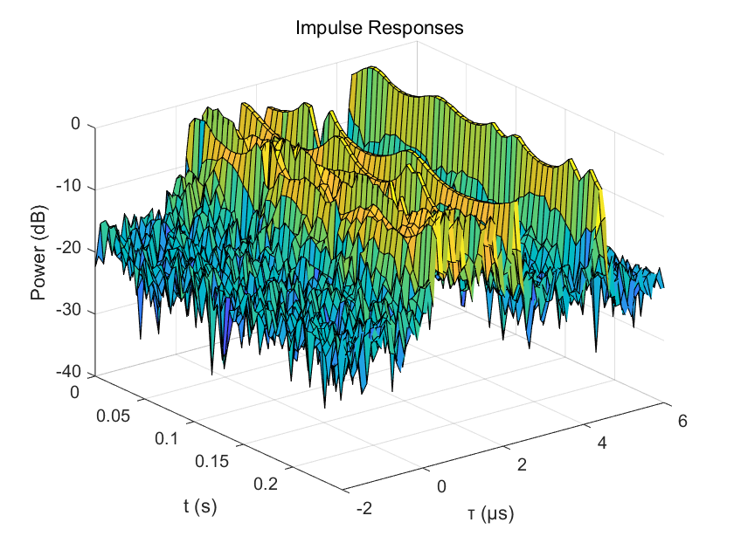

1. LTE







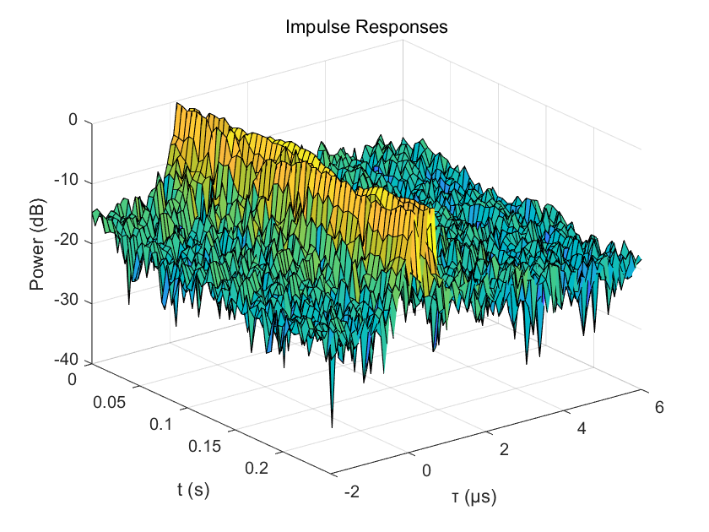

**PDP, delay spreads**

* + Compute and plot power delay proﬁle (PDP), i.e. average power of each tap of the time-variant impulse response, for each measured channel. Normalize so that strongest tap has 0 dB.
  + Compare the PDPs to the PDPs displayed in channel emulator. What diﬀerences do you find?
  + From PDP, calculate absolute delay spread and rms delay spread. Give answers in microseconds.

1. GSM



Absolute Delay Spread: 5.000000 μs

RMS Delay Spread: 0.957098 μs

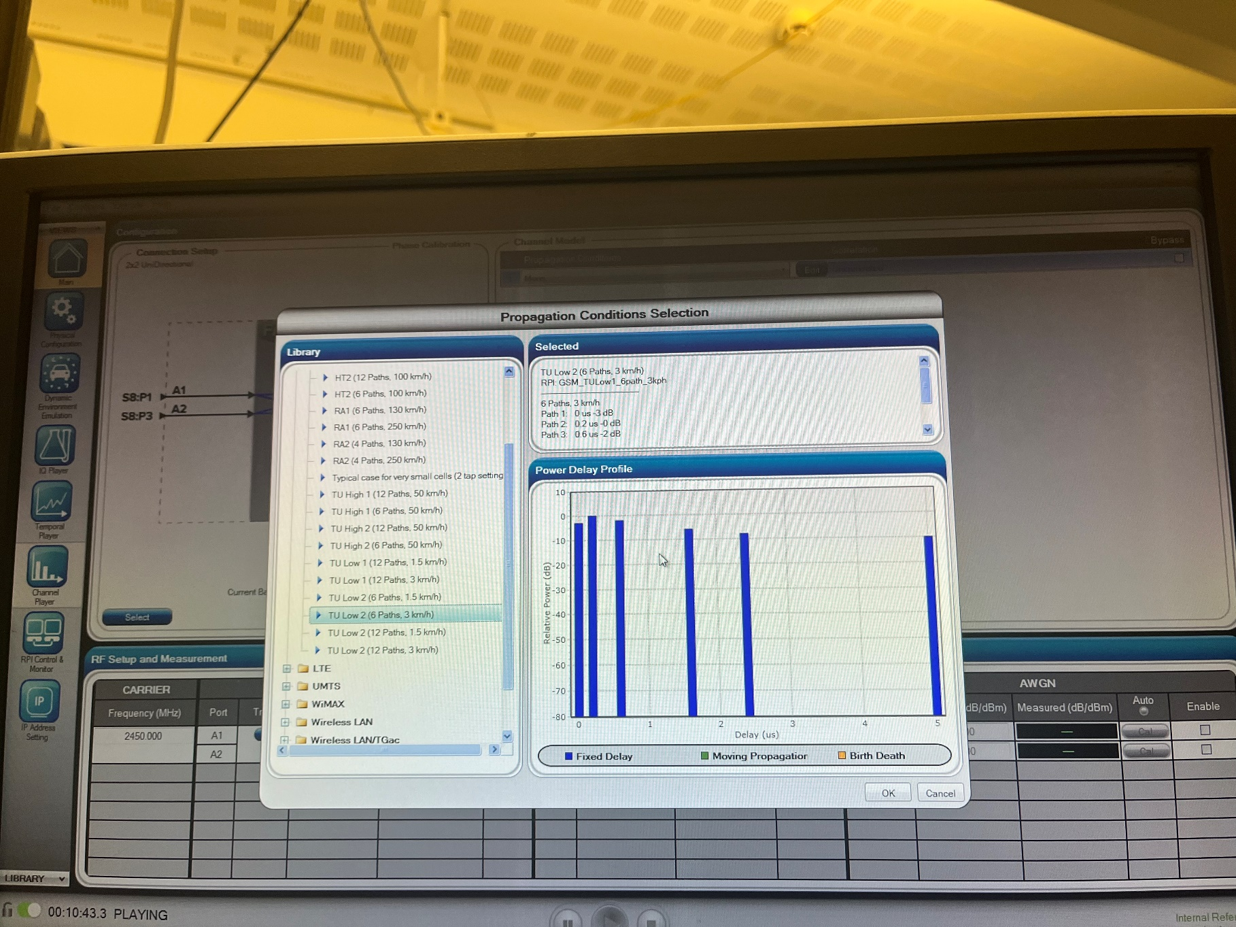

1. LTE



Absolute Delay Spread: 0.400000 μs

RMS Delay Spread: 0.084517 μs

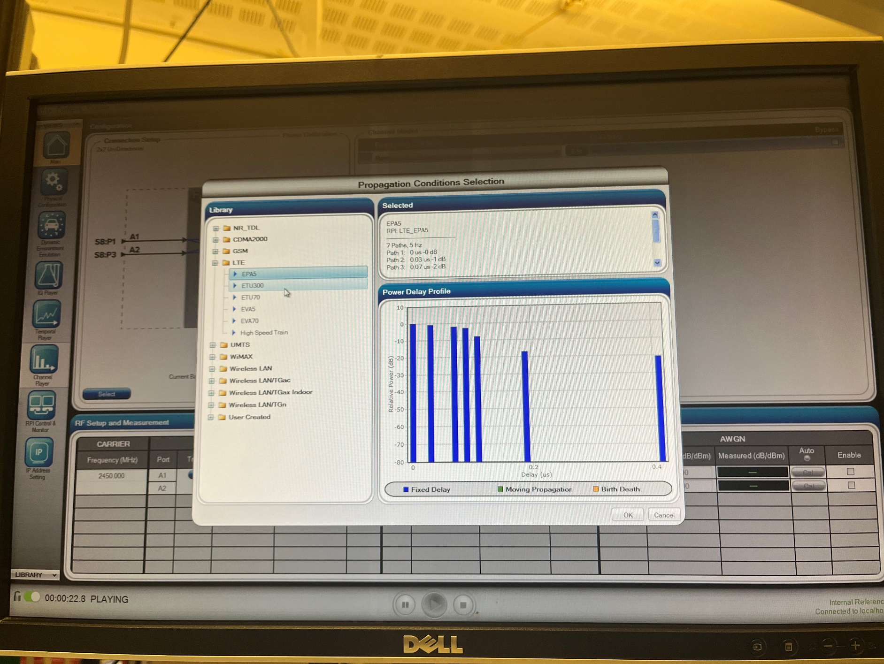

1. Differences

The PDP from the channel emulator is discrete with clear, separate taps, each having significant differences in power levels and specific delays. The delay range in the channel emulator is quite narrow, focused on the initial microseconds, which suggests the presence of strong early reflections. In contrast, the PDP plotted from the data does not have distinctly separate taps, but rather shows a more gradual decay, implying a broader range of delays that could indicate a different type of environment with more diffuse reflections.

**Time-variant channel response, delay-Doppler spread function**

* + Construct the delay-Doppler spread function h(τ, φ) from the time-variant channel response.
  + Plot in one ﬁgure the Doppler spectrum of each channel tap (i.e. at the delays τk where the peaks in PDP are). How much is the Doppler spread?
  + Use the Doppler spread to estimate mobile velocity when carrier frequency is 2.45 GHz.

1. GSM



1. LTE



The Doppler spread is 2.4 Hz.

The mobile velocity is about 0.98 m/s.

**Estimated statistical LTV system functions**

* + Construct the time-variant channel transfer function H(f, t) = Fτ{h(τ, t)} using fft across the τ dimension.
  + Estimate and plot the frequency correlation function φH(Δf, 0). How to estimate? Use xcov or xcorr to take autocovariance/autocorrelation along f axis of H(f, t) and average them along t axis. What is the coherence bandwidth?
  + Estimate and plot the time correlation function φH(0, Δt). What is the coherence time?
  + What is relation between coherence bandwidth and delay spreads?
  + What is relation between coherence time and Doppler spread?

1. GSM





1. LTE





The coherence bandwidth is 100 kHz.

The coherence time is 500ms.

delay spreads = 1/coherence bandwidth

Doppler spread = 1/coherence time